**Practical No. 7**

**Write a simple PHP program to create PDF document by using graphics concepts.**

<?php

require('fpdf.php'); Output:

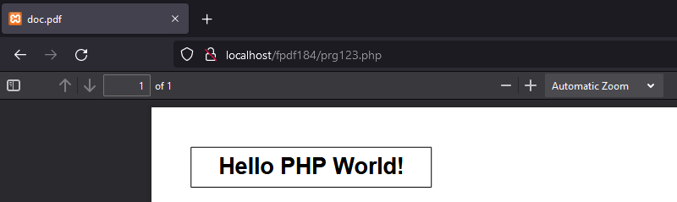$pdf=new FPDF();

$pdf->AddPage();

$pdf->SetFont('Arial','B',16);

$pdf->Cell(60,10,'Hello PHP World!',1,1,'C');

$pdf->Output();

?>

2.

<?php

header("Content-type: image/png");

$handle= ImageCreate(130,50);

$bg_color= ImageColorAllocate($handle,240,240,140);

$txt_color= ImageColorAllocate($handle,0,0,0);

ImageString ($handle, 5, 5, 18, "MSBTE.org.in", $txt_color);

imagepng($handle);

?>

Output:



3.

<html>

<head>

<title> Output:

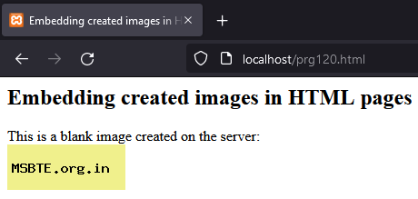Embedding created images in HTML pages

</title>

</head>

<body>

<h2> Embedding created images in HTML pages</h2>

This is a blank image created on the server: <br>

<img src="prg119.php">

</body>

</html>

4.

<?php

$src=ImageCreateFromJPEG('php.jpg');

$width=ImageSx($src);

$heigth=ImageSy($src);

$x=$width/2;

$y=$heigth/2;

$dst=ImageCreateTrueColor($x,$y);

ImageCopyResampled($dst,$src,0,0,0,0,$x,$y,$width,$heigth);

header('Content-Type: image/png');

ImagePNG($dst);

?>

Output:



5.

<?php

$src=ImageCreateFromJPEG('php.jpg'); Output:

$width=ImageSx($src);

$heigth=ImageSy($src);

$x=$width/2;

$y=$heigth/2;

$dst=ImageCreateTrueColor($x,$y);

imagecopyresized($dst,$src,0,0,0,0,$x,$y,$width,$heigth);

header('Content-Type: image/png');

ImagePNG($dst);

?>

6.

<html>

<head>

<title>

Program 124 Output:

</title>

</head>

<body>

<?php

function Factorial($number) {

$factorial=1;

for ($i=1; $i <=$number; $i++) {

$factorial= $factorial*$i;

}

return $factorial;

}

$number=5;

$fact= Factorial($number);

echo "Factorial=$fact";

?>

</body>

</html>

7.

<html>

<head>

<title>Program 125</title></head> Output:

<body>

<?php

function check($number) {

if($number%2==0){

echo "Even";

}

else{

echo "Odd";

}}

$number=20;

check($number)

?>

</body>

</html>

8.

Output:

<?php

function sum($num) {

$sum=0;

for ($i=0; $i < strlen($num); $i++) {

$sum += $num[$i];

}

return $sum;

}

$num="234";

echo sum ($num);

?>

</body>

</html>

9.

<?php

function primeCheck($num) {

$sum=0;

if($num==1)

return 0;

for ($i=2; $i<=$num/2; $i++) {

if($num%$i==0)

return 0;

}

return 1;

}

$num=13;

$flag=primeCheck($num);

if($flag==1)

echo "Prime";

else

echo "Not Prime";

?>